The FAA Center
of Excellence for Technical Training &
Human Performance

RESEARCH ROADMAP 2016 – 2024
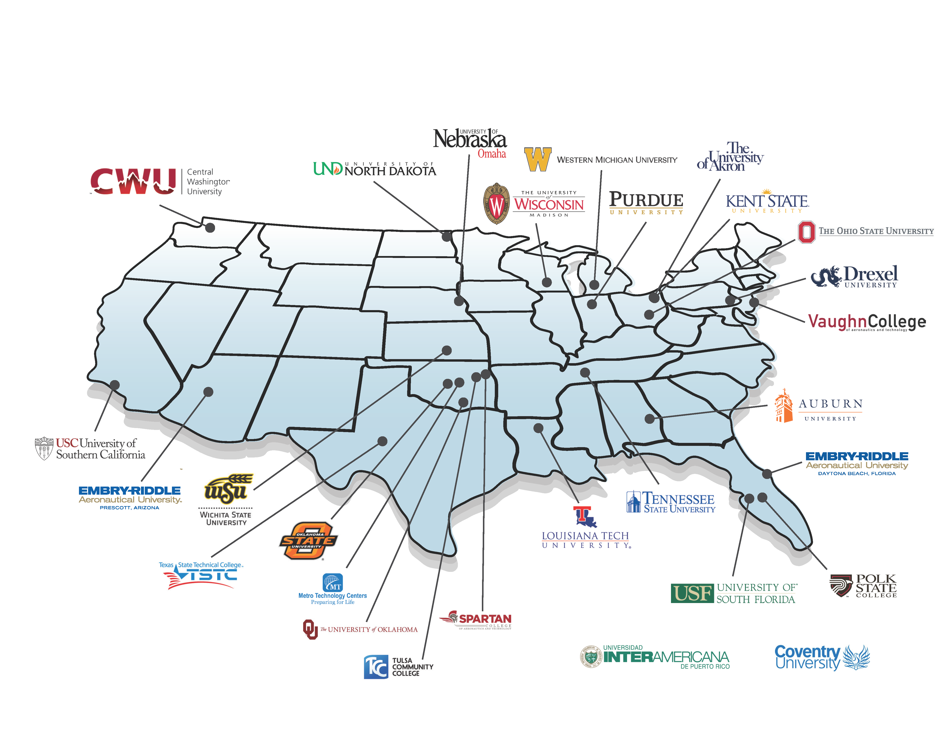

FAA Center of Excellence for
Technical Training and Human Performance
A Strategic Framework for the Future
Research Roadmap
2016 - 2024
www.coetthp.org

In August 2016, through a national competitive process, the FAA awarded a Center of Excellence to a consortium of 16 core institutions, 10 affiliate institutions, and over 45 industry partners. This document serves as a draft of the Center’s research roadmap designed to align the academic and industry research efforts to the priority needs of the FAA.

The COE TTHP initial mission was conducting front-line research to enhance training and technology that decreases the time to deployment of employees for all aviation professions with an emphasis on the needs of the FAA's Air Traffic Organization, NextGen, Flight Program Operations, and Flight Standards. From an August 2016 start-up to today, the FAA COE TTHP has been awarded over 90 research projects designed to ensure that the FAA will develop a highly trained technical workforce. By examining human factors issues and incorporating advanced training technologies to enhance performance, the FAA is better positioned to produce a higher level of mission-ready employees in the future.

The FAA COE TTHP is confident that the academic and industry partners within our consortium demonstrate the specific past performance and present capability needed to easily and swiftly respond to and meet any new research requirements affiliated with the Title VI - Aviation Workforce needs mentioned within H.R. 302.

FAA Centers of Excellence Program Overview

The FAA COE program was established by the Omnibus Budget Reconciliation Act of 1990, Public Law 101-508, Title IX, Aviation Safety and Capacity Expansion Act. COEs are established through cooperative agreements with the nation's premier universities and their members and affiliates, who conduct focused research and development and related activities over a period of 10 years. The COE program facilitates collaboration and coordination between government, academia, and industry to advance aviation technologies and expand FAA research capabilities through congressionally required matching contributions. COE members cost-match FAA grant awards to establish; operate; and conduct research, with contributions from non-federal sources and may also provide additional contributions through cost-share contracts. Over the life of the program, the COE universities, with their non-federal affiliates, have provided more than $300 million in matching contributions to augment FAA research efforts. Through these long-term, cost-sharing activities, the government and university-industry teams leverage resources to advance the technological future of the nation's aviation industry while educating and training the next generation of aviation researchers and professionals.

Currently, the FAA oversees the following active COEs:

Center of Excellence  Title/Area | Lead  Institutions | Established
Joint Center for Advanced Materials Research | Wichita State University and  University of Washington | 2004
Commercial Space Transportation | Florida Institute of Technology | 2010
General Aviation Safety | Purdue University | 2012
Alternative Jet Fuels and Environment | Massachusetts Institute of Technology and Washington State University | 2014
Unmanned Aircraft Systems | Mississippi State University | 2015
Technical Training and Human Performance | Embry-Riddle Aeronautical University, University of Oklahoma, and Wichita State University | 2016

FAA COE for Technical Training and Human Performance Overview
The FAA Center of Excellence for Technical Training and Human is focused on research and development for air traffic controllers, aviation safety inspectors, engineers, technicians, and pilots. Six original goals were identified by the Air Traffic Organization as priorities in 2016. The COE TTHP aligned the initial research projects to the goals listed below:
- Redesign the platform for content management and development;
- Update the development processes for course management and maintenance;
- Expand and enhance the partnerships among FAA, academia, and industry to define future learning;
- Develop implementation and integration strategies to utilize available technology that will improve the learning environment;
- Establish communication and transparency with stakeholders; and
- Continually align business goals to organizational requirements for growth and development.

Research Roadmap
The COE TTHP created a Research Roadmap for the first phase of the Center’s establishment, August 2016 to August 2024. This initiative utilized a variety of mechanisms, including surveys, focus groups, and industry association conferences. After analyzing an expansive list of research questions, the Center membership organized them into four main research themes focusing on (1) workforce development and training, (2) human factors, (3) safety, and (4) analytics. The updated research themes, illustrated in the figure below, provide a structure to guide the effort of the Center. These themes help align the research capabilities of the Center so that the Federal Aviation Administration, other units of government, and industry, can easily identify researchers who can provide analysis and solutions.

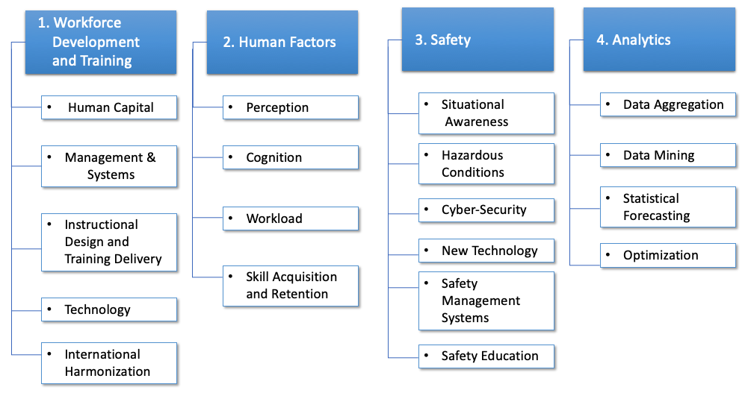
The current research roadmap for the August 2016 to August 2024 time frame builds on the theme developed for the first phase by providing examples of completed projects supporting FAA initiatives. The themes identified to date indicate the broad scope of the FAA COE TTHP’s capacity and interests. This reflects significant efforts by the FAA COE TTHP’s academic, industry, and government stakeholders to identify salient research topics in the areas of technical training and human performance especially where those questions addressed shared concerns across the aviation field and aligned with the capabilities and interests of researchers who contribute to the Center’s capability.

The previous roadmap featured a narrative of key research questions. The narrative populated the four research themes with lists of specific research questions drawn from academic, government, and industry present at the FAA COE TTHP Phase 1 (2016 – 2024) administrative and technical meetings and the research roadmap workshop held in Norman, OK, on June 4 - 5, 2018. The research questions can be found in the Appendix and the COE TTHP website.

Research Roadmap Main Research Themes

Workforce Development and Training
The Workforce Development and Training theme addresses the need to modernize content and course delivery using new technology and develop instructional design strategies with an emphasis on linking curriculum to specific competencies and job tasks. In addition, the research seeks to identify improvements to recruitment, hiring, pre-screening, on-boarding, and placement practices. Key overarching topics within this theme include skill development and transfer, system-level training, and developing consistencies in nomenclature, training methods, and problem-solving approaches throughout aviation organizations.

Under this theme, specific areas of workforce development and training that lie within the Center’s capabilities are:
- Human Capital – This research examines the skills, knowledge, communication styles, and/or other assets of individuals used to create value for the individuals and their employers in an effort to enhance organizational culture and work environment. Research areas within Human Capital include recruitment and Selection, Hiring, Retention, Performance, Knowledge Management, Change Management and Organizational Culture.
- Management and Systems – This research explores the effectiveness of systems that organize training curricula, schedules, grading, records, and training history as well as the effective delivery of e-learning courses.
- Instructional Design and Training Delivery – This research explores solutions for increasing the effectiveness of training design and development as well as enhancing training delivery and outcomes across all aviation sectors. Research areas within Instructional Design and Training Delivery include Design and Development, Delivery and Outcomes, and Standardization.
- Technology – This research seeks to transform the training environment by incorporating new and future innovations in training technologies in an effort to enhance human performance including: Evaluation and Implementation, Mobile Applications, Artificial Intelligence, Augmented & Virtual Reality Simulation, Gamification and Unmanned Aerial Systems.
- International Harmonization – This research focuses on the globalization of standards in the areas of training, operations, safety, and security. Research in this area emphasizes the need to align training with local needs while maintaining global standards for performance.

Human Factors
The Human Factors research theme focuses on the human factors that affect job performance and environmental factors that impact the safe and effective performance of jobs and tasks, workload, and skill acquisition. Research also may focus on assessing and preventing the negative effects of high-risk and high workload job tasks that involve changes in brain activity, eye movement, and/or hearing; decreased cognition; and increased heart rate, stress, and/or fatigue. Skill acquisition and retention may be used to measure if perception or cognition is delayed or decreased due to an intense or high workload.

Under this theme, specific areas of human factors research that lie within the Center’s capabilities are:

- Perception – Research that explores processing of the information we receive from the environment. Some key research areas include assessment and evaluation of auditory and visual perception, exploring the contributory factors impacting human perception in aviation as well as potential technologies, such as eye-tracking, that can help better understand differences in visual perception within and across different aviation job areas as well as trainees through their skill acquisition.
- Cognition and Human Performance – Cognition is closely related to perception, and the research focuses on how the information is being processed, learned, memorized, etc. Research areas fall within evaluation of cognitive abilities, cognitive impact analysis, new analytics for cognitive performance and cognitive workload, impact of cultural or generational difference on the use of technology in the processing of information and decision making, attention, human behavior, situation awareness, communication, crew resource management, ergonomics, and usability studies.
- Workload, Fatigue, and Stress – These are critical factors impacting human performance and safety. Hence, the research seeks new technologies and analytics to detect and track stress and fatigue levels as well as mitigations strategies and training approaches to minimize the adverse impacts of fatigue and stress.

- Complex Systems, Skill Acquisition, and Retention – Research that focuses on learning and training efficiencies, skill retention strategies and measurement, human-in-the-loop studies, NextGen approaches, evaluation of skill learning approaches, metrics, and best practices, teachable systems, adaptive training, augmented and virtual reality, studies including flight training devices and simulators, and interface design.

Safety
The Safety research theme focuses on the relationships among safety, technical training, and human performance, and seeks to develop valid and reliable tools, techniques, and strategies for both mitigation and prevention of intentional and unintentional errors. Workforce safety is a critical issue across aviation and other fields, and projects developed for aviation safety have cross-industry applications to areas such as medicine and nuclear power. Critical needs to prevent and predict complacency and decision error, as well as the implementation of effective training protocols and system management tools where appropriate have risen in recent years. Safety as it relates to technical training and human performance encompasses all levels of the national airspace system, from individual factors, such as fatigue and stress, to team and department level factors around decision making and group risk-taking, to organizational system failures regarding safety culture, reporting systems, and Just Culture.
Under this theme, specific areas of Safety research that lie within the Center’s capabilities are:
- Situation Awareness – Research that includes cognition and perception, human/technology interaction, team performance and shared information biases, heuristics and decision-making.
- Hazardous Conditions – Research that involves personnel training, workforce development, FOD, runway incursions, fatigue and stress prevention and mitigation.
- Safety Culture – This research focuses on organizational culture, change management, knowledge management, and NextGen safety.
- New Technologies in the NAS (NextGen, UAS, etc.) – Research that encompasses human/technology integration, training, performance management, cognition and perception, fatigue and stress, human learning and performance.
- Effective Safety Training & Training ROI – Research that analyzes the safety training techniques and principles. This area of research also highlights the return on investment these programs provide, helping companies to see the benefit to training programs that cover a variety of safety components.

Analytics
The Analytics research theme considers the development of data analytics tools and applications to collect, manage, and analyze data from curricula, training performance records, and other sources to develop improved training solutions and enhanced operational performance metrics.

Under this theme, specific areas of analytics research that lie within the Center’s capabilities are:
- Data Aggregation – Research that focuses on collecting, managing and integrating vast amount of data from curricula, training performance records, and other sources. Research areas within Data Aggregation include integration of training data in different data systems across the aviation enterprise; utilization of artificial intelligence (AI) in data collection, management, and analysis; data integration for identification and mitigation of risks and safety hazards.
- Data Mining – Research that involves utilizing data analytics tools and artificial intelligence (AI) applications to analyze data to develop improved training solutions and enhanced operational performance. Research areas within Data Mining include information discovery for training and staffing process improvement, better decision making, and operational excellence; intelligent identification and mitigation of risks and safety hazards.
- Statistical Forecasting – Research that leverages statistical analysis and data analytics for accurate forecasting of future trends and demands to aid in various decision making and planning processes. Research areas within Statistical Forecasting include identification of at-risk trainees and development intervention plans; expertise gaps prediction and staffing planning; data collection plan for adaptive learning and other aspects of training; development of models that combine expert opinions and quantitative data for better decision making; identification of best practices for documenting training successes and failures.

- Optimization – Research that explores the use of data analytics to optimize the various processes and operational performance across the aviation enterprise. Research areas within Optimization include training schedules optimization for maximizing throughput of trainees and maximizing learning; optimization that balances multiple objectives with multiple system requirements and constraints, learner engagement and learning outcomes improvement with consideration of both subjective and objective performance evaluations; development of optimization algorithms for various training and safety process improvements.

Examples of Current Research Performance
Evaluation of Mobile Learning Applications for ATO Technical Training: The FAA ATO Training Technologies Group is working with the University of Nebraska-Omaha, University of North Dakota, Wichita State University, University of Oklahoma, Inter American University of Puerto Rico, Tulsa Community College, Auburn University, Purdue University, The Ohio State University, and University of Akron to evaluate the usability, skill and competency mastery, and learning retention/transfer to practice of mobile learning applications for air traffic controllers and technicians. The team will conduct an experiment across eight institutions, with a sample size of N=200, to track the trends of novice to expert MLA users. Findings will contribute to the FAA governance process for the selection of future training technology. Rigil Corporation is the industry partner assigned to this study.
FAA Flight Operations Safety Assessment: Led by researchers at The Ohio State University and sponsored by the Flight Program Operations Safety Division, this project is designed to develop, launch, and analyze initial survey data that obtains flight crew perceptions, understandings on flight standards, training received, crew resource management, Captain’s authority, and expectations. The sample size for the study is 135 (100 federal pilots and 35 contract pilots). An initial report will be completed and shared with the FAA to allow the organization the ability to implement immediate recommendations.
Human Factors Training for FAA Aviation Safety Specialists within Aircraft Certification and Flight Standards: FAA Aviation Safety (AVS) is working with Embry-Riddle Aeronautical University, Kent State University, and Akron University in an effort to develop the curriculum for three introductory-level human factors training modules and evaluate their effectiveness. These modules must be accommodating to the limitations of FAA equipment.

Examples of Past Research Performance
Analysis of Technical Operations Job Tasks and Air Traffic and Tech Ops JTA Workbooks Database: Researchers from Drexel University and Purdue University and sponsored by the Air Traffic Organization leveraged task analytic methods to research current job tasks for air traffic controller and technician personnel embedded in existing curriculum. The researchers used a modeling approach to address courses that were outdated or had no task alignment. At the end of the project, a job task database was created for the FAA.

Characterization and Application of Air Traffic Controllers Visual Search Patterns and Control Strategies for Efficient and Effective Training: Through the research effort of the University of Oklahoma and sponsored by the FAA ATO Human Performance Team and FAA Civil Medical Aerospace Institute, this research characterized and classified the visual scanning patterns and control strategies of various air traffic controllers by collecting eye movement data. Results of the study included incorporating the eye tracking patterns of expert ATCs into new training technology designed to improve visual scanning performance.

Effective Training and Checking Methods for the Emerging Pilot Workforce: Led by researchers at Auburn University and sponsored by the NextGen Organization Human Factors Division, this research grant will provide scientific and technical data on effective training and checking methods for the current and projected pilot workforce, with emphasis on pilot information management, decision-making, and command judgment.

Employee Footprint: 21st Century Approach towards Employee Development: Researchers from Inter American University of Puerto Rico, Auburn University, and The Ohio State University came together to research ways to transform employee development training for the FAA’s Flight Standards Service Division. The team focused on a cost-effective approach leveraging best practices, meeting safety assurance standards, and supporting employee growth and job requirement advancement by strengthening organizational culture. KeyBridge Technologies, Inc., supported the research.

FAA Air Traffic Organization Training Culture Change: Researchers from Embry-Riddle Aeronautical University were tasked with supporting changes to policies, procedures, and practices in the FAA Air Traffic Organization (ATC) training performance. The deliverable at the conclusion of the project was a detailed training culture change management plan (TCCMP), synthesized from best practices researched through relevant literature.

Fleet Assessment/Modernization Study: Led by researchers at Embry-Riddle Aeronautical University and sponsored by the Air Traffic Organization Flight Program Operations Division. This two-phase project uses modeling and simulation to assess the Division’s fleet and recommend consolidation and acquisition strategies. The team is also recommending fleet integration and maintenance plans, man-power and new personnel mission planning, and business case strategies using modeling techniques.

International Harmonization and Integration: Research led by Drexel University and The Ohio State University worked with the Air Traffic Organization’s Technical Training Division to create an approach for developing, furthering, and maintaining close relationships and partnerships with international groups on harmonizing training for aviation professionals. This project demonstrated the importance of international safety and the systematic review revealed opportunities to minimize the isolation of FAA ATC technical training on a global scale. ​

Modernization of Airworthiness Effort: The Air Traffic Organization’s Aircraft Certification Service Enterprise Operations Division is working with Embry-Riddle Aeronautical University in a multi-year project to create training materials for an airworthiness certification program; the project is an extension of the Create COE Strategic Framework effort, titled “Modernization of Airworthiness Effort.” The short courses developed will be infused into engineering education and professional training at a national level to support defining airworthiness engineering as a new formal discipline.

Technical Operations: Airway Transportation Systems Specialist Training Analysis: The Air Traffic Organization’s Safety and Technical Training Division worked with Western Michigan University review the initial and recurrent training processes of Airway Transportation Systems Specialists (ATSS). A gap analysis was conducted of the existing training and needs of ATSS, and an updated process map was created for visualizing and validating the training track and in-field process flow experienced by the technician to reduce outage restoration time and erroneous/waste of limited parts logistics.

Training of Pilots and Air Traffic Controllers in Weather-Related Decision Making Using Probabilistic Hazard Information Displays: Through the research efforts of Embry-Riddle Aeronautical University, the University of Akron, and the University of Wisconsin – Madison, the team created two prototypes of simulation-based weather scenarios for pilots (a weather engine ClimaDrive) and air traffic controllers (a MATLAB-based simulation program). The prototypes include hazard displays and probabilistic displays to improve pilots’ decision-making skills and enable controllers to rapidly and accurately assess emerging weather situation to effectively and safely vector aircraft around weather. Industry partner Pilot Training System supported the effort.

Ultra Lightweight VOR/ILS Receiver and ILS Zone 3 Measurement: Researchers at the University of Oklahoma and Oklahoma State University are working together with industry partners at Garmin International and Essential Aero on projects sponsored by the ATO Flight Program Operations Division. The research will develop a novel, low cost, size, weight and power C-SWaP navigational receiver enabling the feasibility of performing in-air, high resolution ILS signal integrity inspection using a low-cost UAS platform. The outcome of these projects is to validate the reliability of using UAS for future flight inspections. OU and OK State will complete follow-on projects after this study to improve flight inspection modeling and simulation and conduct UAS combat flight inspection.

Industry Partners
The Center’s industry partners are leaders in the fields of aerospace, artificial intelligence, learning development and curriculum architecture, software programming, training and simulation, and many other areas. Academic researchers collaborate with industry partners to strengthen the project team. Industry partners provide consultation, aid in development of prototypes, and provide general assistance throughout the project’s period of performance. More information on the industry partners may be found on the COE TTHP Webpage.

Academic Core University Capabilities
The core university partners of the FAA COE TTHP provide a wide range of strengths in faculty, students, and infrastructure that address the Center’s research needs for FAA’s customers. The table below provides an illustration of the strengths of each core institution for the research themes areas. A list of our core and affiliate institutions may be found in the Appendix and on the COE TTHP Website.

Rating of University Strengths in COE TTHP Research Themes
(Blue - Very Strong, Yellow = Moderately Strong, Grey = Not Our Area of Expertise):

 | Workforce Development | Human Factors | Safety | Analytics
Auburn University
Drexel University
Embry-Riddle Aeronautical University
Inter-American University
Oklahoma State University
Purdue University
The Ohio State University
Tulsa Community College
University of Akron
University of Nebraska – Omaha
University of North Dakota
University of Oklahoma
University of Wisconsin – Madison
Western Michigan University
Wichita State University

Funding Sponsors

The FAA COE TTHP has identified a number of potential funding sponsors with interests in the above main research and cross-cutting research themes for its research and development efforts. Within the FAA, the Center has the capacity to provide research services in the following substantive areas or lines of business: Technical Operations, Air Traffic Control, NextGen Training, Flight Standards, Flight Program Operations, Airports (Design and Safety), Aircraft Certification, as well as Management and Administration. Outside the FAA, the Center is well positioned to support research relevant to the Department of Defense and the National Aeronautics and Space Administration.

From 2016 through 2020, the FAA has sponsored over $7M in research, funded by the following divisions:

- FAA Air Traffic Organization (primary sponsor): curriculum needs analysis, learning management system analysis, course development, training standardization, modular and part-task training delivery, augmented and virtual reality training, mobile learning application prototypes, gamification prototypes
- FAA Flight Program Operations: fleet modernization, unmanned aircraft system flight inspection feasibility, ultra lightweight VOR/ILS receiver, ILS zone 3 measurement, improvements of flight inspection antenna modeling and simulation, UAS combat flight inspection, part 141 pilot school feasibility, flight operations safety assessment
- FAA NextGen: emerging pilot workforce training enhancements
- FAA Flight Standards: employee hiring and development best practices, training content management, training technology best practices
- FAA Aircraft Certification Services/Aviation Safety: modernization of air worthiness training

It is important to note that the Center’s leadership, core members, affiliate institutions, and industry partners who make up the FAA COE TTHP recognize that technical training and human performance are moving targets in aviation and other industries where technology is evolving quickly, work forces are in transition, and the demands placed on the infrastructure and the people who operate within it and maintain it are challenging efforts to operate safely and efficiently. The Center has been successful through its ability to adapt to a changing environment; engaging with new sponsors; constantly evaluating new technologies; and working with the FAA, industry partners, academic leaders, and others to identify new areas of research opportunities.

Appendix

Appendix A: List of COE TTHP Core University Partners
Auburn University
Drexel University
Embry-Riddle Aeronautical University
Inter-American University
Oklahoma State University
The Ohio State University
Purdue University
Tulsa Community College
The University of Akron
University of Nebraska – Omaha
University of North Dakota
University of Oklahoma
University of Wisconsin – Madison
Western Michigan University
Wichita State University

Appendix B: List of COE TTHP Affiliate University Partners
Central Washington University
Coventry University
Louisiana Tech University
Kent State University
Metro Technology Centers
Polk State College
Spartan College of Aeronautics and Technology
Tennessee State University
Texas State Technical College
University of Southern California
University of South Florida
Vaughn College

Appendix C: List of COE TTHP Industry Partners
 | 1st American Systems and Service
 | Adacel
 | Addx Corporation
 | Air Traffic Simulation, Inc.
 | American Airlines
 | American Institutes for Research
 | Army Gaming Studio
 | ATA LLC
 | ATAC
 | AVT Simulation
 | Blackboard
 | C² Technologies
 | Chickasaw Nation Industries
 | Choctaw Nation of Oklahoma
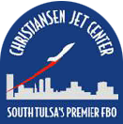 | Christiansen Aviation
 | CI² Aviation
 | Computer System Designers
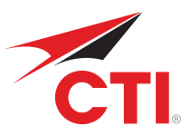 | Crew Training International
 | CSSI
 | Delta Airlines
 | Eduworks Corporation
 | Essential Aero
 | Florida NextGen Test Bed
 | Garmin International
 | Frasca International, Inc.
 | General Dynamics IT
 | Infina, Ltd.
 | Instructure, Inc. & Canvas Network
 | JMA Solutions
 | KeyBridge Technologies
 | Leidos
 | Metacraft
 | Northrop Grumman
 | Orion America Technologies
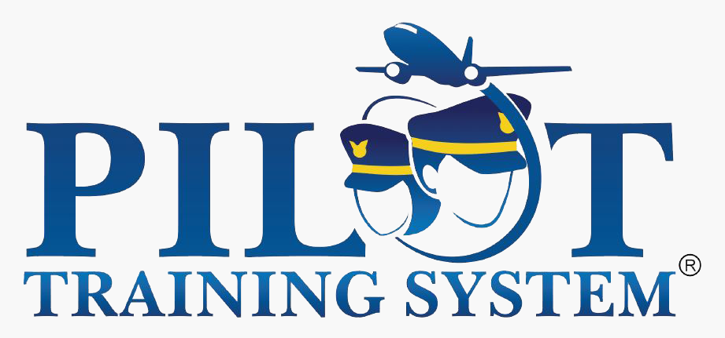 | Pilot Training System
 | Rigil Corporation
 | Robinson Aviation
 | RTSync
 | SAIC
 | Serco, Inc.
 | Skyguide
 | Skymantics LLC
 | SkySoft ATM
 | TetraTech
 | The Washington Consulting Group, Inc.
 | TransLumen Technologies
 | UFA, Inc
 | USAF Pilot Training Next
 | Veracity Engineering
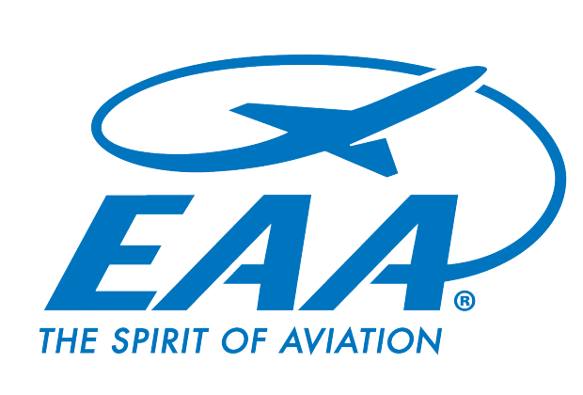 | Virtual Flight Academy
 | Volpe Center
 | WeyTec

Appendix: List of Hyperlinks in the Research Roadmap
URL | Description | Page(s)
https://coetthp.org/key-research-questions/ | Research Questions on COE TTHP Website | 4, 5
https://coetthp.org/workforce-development-and-training/ | Workforce Development and Training page on the COE TTHP Website | 5
https://coetthp.org/research-projects/coe-strategic-framework/ | Modernization of Airworthiness Effort research description on the COE TTHP Website | 6
https://coetthp.org/completed-research-projects/employee-footprint-21st-century-approach/ | Employee Footprint: 21st Century Approach towards Employee Development research description on the COE TTHP Website | 6
https://coetthp.org/human-factors/ | Human Factors page on the COE TTHP Website | 7
https://coetthp.org/completed-research-projects/training-of-pilots-and-atcs-in-weather/ | Training of Pilots and Air Traffic Controllers in Weather-Related Decision Making Using Probabilistic Hazard Information Displays research description on the COE TTHP Website | 7
https://coetthp.org/research-projects/effective-training-and-checking-methods/ | Effective Training and Checking Methods for the Emerging Pilot Workforce research description on the COE TTHP Website | 8
https://coetthp.org/safety/ | Safety page on the COE TTHP Website | 8
https://coetthp.org/completed-research-projects/international-harmonization/ | International Harmonization and Integration research description on the COE TTHP Website | 9
https://coetthp.org/analytics/ | Analytics page on the COE TTHP Website | 9
https://coetthp.org/research-projects/fleet-assessment-phase-ii/ | Fleet Assessment/Modernization Study research description on the COE TTHP Website | 10
https://coetthp.org/research-projects/ils-zone-3-measurement/ | ILS Zone 3 Measurement research description on the COE TTHP Website | 10
https://coetthp.org/about/leadership/university-partners/ | University Partner List from the COE TTHP Website | 10
https://coetthp.org/about/leadership/industry-partners/ | Industry Partner List from the COE TTHP Website | 11

Appendix: Examples of Future Research Capabilities

The FAA COE TTHP partners have a wide range of research specializations, strengths, and capabilities. This appendix serves as a reservoir for potential areas of research.

Workforce Development and Training
- Advanced Simulation Training
- Augmented and Virtual Reality Training
- Mobile Learning Application Training
- Gamification Training

Unmanned Aircraft Systems (UAS)
- UAS CSwAP navigational receiver, antenna modeling and sensing, radar, data collection for flight inspection and weather
- UAS design and mission operations
- UAS detect and avoid
- UAS training

Appendix: COE TTHP Research Questions

Key Research Questions

Workforce Development and Training
Human Capital – this research examines the skills, knowledge, communication styles, and/or other assets of individuals that can be used to create value for the individuals and their employers in an effort to enhance organizational culture and work environment.
Recruitment and Selection:
- How can a comprehensive pre-employment screening process (e.g. Review of credentials, assessment of cognitive skills, classification of personality types and leadership styles, and/or review of prior experience) be incorporated into the information used during the recruitment and selection process?
- What are the best practices for successful early engagement in the aviation field within the K-12 educational system (e.g., formal and informal STEM programming, Junior ROTC Program, internships, mentoring, etc.)?
Hiring:
- How can performance assessment results of FAA internship candidates be tracked and incorporated (e.g., prior learning and/or experience credit) into the information used during the hiring and onboarding process?
- How do you create and implement an adaptive training model aligned with pre-screening findings identified in the hiring process to address the specific skill development needs of each employee?
- How can prior learning credits be used to expedite the time to certification of aviation professionals transitioning from the military to the FAA?
Retention:
- What are the retention rates associated with current candidate selection processes, on-boarding techniques, and other training approaches?
- What is the impact on retention if training candidates are pre-assigned to trainers of same or similar learning styles and personality types?
- What is the impact on retention if aviation professionals participate in cohort learning organized around same or similar learning styles and skill levels?
Performance:
- To what extent can personal background, prior professional experience, and prior training and qualifications predict and/or explain initial training performance and early on-the-job performance?

Knowledge Management:
- How can the FAA implement a knowledge management plan to capture the performance trends and experience lessons of professionals prior to retirement?
- What is the best strategy for translating the high performance strategies of expert professionals to content and process updates within the experiential training environment?
Change Management:
- What are the best change management process recommendations for significantly improving the acceptability and support of training administrators and trainers in the use of technology and innovative training practices for next generation aviation professionals?
Organizational Culture:
- How do you improve the intergenerational culture and communication preferences of a diverse trainer/trainee learning environment and maintain training quality?
- What are the advantages of emphasizing measures of success rather than measures of failure in the training feedback model?
- How do you transform the training feedback model from an emphasis on measures of failure to an emphasis on measures of success?
- How do you provide early positive exposure and integration into the FAA’s organizational culture within a privatized training environment?
Management and Systems – this research explores the effectiveness of systems that organize training curricula, schedules, grading, records, and training history as well as the effective delivery of e-learning courses.
- What solutions can be implemented to assist the FAA in reaching its desired state for the Enterprise Learning model?
- What is the infrastructure capacity by facility and across facilities for the accommodation and successful implementation of the deployment of new training technologies?
- What is the staffing capacity by facility and across facilities for the accommodation and successful implementation of the deployment of new training technologies?
- Are existing FAA systems (e.g., CEDAR, FALCON, TSS) being utilized to the fullest extent of their capabilities? If not, what are the impediments or constraints to full and effective utilization?
- What reengineering is required to continue utilizing existing FAA systems (e.g., CEDAR, FALCON, TSS) for emerging needs?
- What are the best practices for archiving training content (e.g., catalogs, manuals, courses, materials)?
- What best practices exist for tracking the lifecycle of employee learning (e.g., from recruitment to retirement, initial training, advanced training, remedial training, refresher training)?
- How can data from the effective tracking of the lifecycle of employee learning be used to improve training and learning?
- How can a tracking system of new and/or evolving technologies help determine the priority of selection for implementation within the training environment?
Instructional Design and Training Delivery – this research explores solutions for increasing the effectiveness of training design and development as well as enhancing training delivery and outcomes across all aviation sectors.
Design and Development:
- What is the feasibility of applying the agile model to the instructional design of aviation courses across professions?
- How can current training be redesigned and enhanced by incorporating adaptive instruction?
- How can current training be redesigned to incorporate future competencies needed for NextGen?
Delivery and Outcomes:
- What are the best practices for increasing the readiness of the training organization to deliver training across multiple modalities (e.g., mobile apps, e-learning platforms, simulations)?
- What is the impact on training outcomes per modality when content is delivered via multiple modalities (e.g., mobile apps, e-learning platforms, simulations)?
- Does the sequencing of modality training improve training outcomes?
- Are certain modalities more appropriate for initial training versus recurrent or refresher training?
- Which courses or topics are most cost-effectively delivered in-person?
- Which courses or topics are most cost-effectively delivered virtually?
- What impact does facility location and/or facility type have on the performance of training candidates (e.g., time to certification, safety of the NAS, etc.)?
- What is the impact on training outcomes if aviation professionals participate in an initial training program with curricula drawn from professions with same or similar competencies?
- What is the impact on training outcomes if aviation professionals participate in competency and facility-based advanced training?
- What is the impact on training outcomes if aviation professionals increase participation in just-in- time (micro learning) training?
- What is the impact on training outcomes if aviation professionals participate in cohort learning within same or similar skill levels?
Standardization:
- How can core and/or basic skills be introduced consistently throughout the training continuum (e.g. K-12 to vocational to 2-year or 4-year degree to placement within an aviation career)?
- What are the best practices for standardization of core competency training?
- What is the feasibility of standardizing training of core competencies within specialized training areas (e.g., En Route, Tower, TRACON)?
- What are the best practices for standardization of training evaluation procedures across facilities?
- How can best practices from the DoD training organization be incorporated in the instructional design and training delivery efforts of FAA training organizations?
Technology – this research seeks to transform the training environment by incorporating new and future innovations in training technologies in an effort to enhance human performance.
Evaluation and Implementation:
- What are best practices for identification and prototyping of new training technologies?
- What is the interoperability between varying learning technologies for the same area, topic, and/or course?
- How do we incorporate a cost/benefit life cycle analysis into the identification and selection of new technologies (e.g., long-term maintenance costs, training costs, etc.)?
- What technology is best suited for performance support systems vs. training applications?
- What are best practices for using technology to connect elements of training (e.g., blended learning)?
- How can you create the appropriate level of fidelity for each advanced training technology to ensure effective transfer of learning for each professional area?
- What are the technological advances in hazardous weather information dissemination across professions?
- How can advances in training technology assist with measuring and tracking certification of performance?
- How effectively do advanced technologies help overcome physical constraints on human performance that have historically led to the disqualification of otherwise trainable candidates (e.g., color blindness, prosthetics, etc.?)
- What are the lessons learned from incorporating new and/or evolving technologies across agencies (e.g. FAA, DoD, NASA)?
Mobile Applications:
- How can just-in-time (micro learning) training for remedial or refresher curricula be delivered via mobile applications?

- How can just-in-time (micro learning) training for facility specific curricula be delivered via mobile applications?
Artificial Intelligence:
- How can artificial intelligence support adaptive learning within the simulation environment (e.g. scenarios based on high traffic, hazardous conditions, etc.)?
- How can artificial intelligence reduce deviations from standard operating procedures?
- How can artificial intelligence be used within e-learning modules to enhance soft skills and/or leadership training of aviation professionals (e.g., stress management, change management, accountability, etc.)?
Augmented and Virtual Reality Simulation:
- What are the benefits of utilizing augmented reality and/or virtual reality as a
learning tool?
- Can augmented reality and/or virtual reality be used to improve remedial or refresher training?
- How does utilizing augmented reality and/or virtual reality in remedial or refresher training impact intergenerational learners?
- What specific training areas or topics are ideal for utilizing virtual reality technology vs. full simulation technology in an effort to decrease training costs while maintaining training outcomes?
- How can just-in-time (micro learning) training for remedial or refresher curricula be delivered via augmented or virtual reality simulation?
- How can just-in-time (micro learning) training for facility specific curricula be delivered via augmented or virtual reality simulation?
- How can virtual reality training applications increase the readiness of training candidates for hazardous airport environments (e.g., mountainous terrain; hazardous weather – ice, snow, tornadoes, hurricanes; and wildlife hazards)?
- How can successful implementation of augmented or virtual reality learning tools be applied from one aviation sector to another (e.g. technicians to safety inspectors, etc.)?
Gamification
- What is the appropriate level of application of gamification within the training environment across aviation professions?
- What are best practices for implementing game mechanics into the training environment?
Unmanned Aerial Systems
- What is an adequate level of exposure to sUAS training curricula to ensure the safety of the NAS by aviation profession?

- How can sUAS be utilized to supplement live instruction within the training environment (e.g., aircraft inspection)?
- How can sUAS assist with hazardous weather or hazardous terrain training to improve data collection and communications across aviation professions?
International Harmonization – this research focuses on the globalization of standards in the areas of training, operations, safety, and security. Research questions in this area emphasize the need to align training with local needs while maintaining global standards for performance.
- What are the best practices for finding a common nomenclature for training in areas across the field of aviation?
- How can we maintain respect for local and national customs and practices while effectively harmonizing essential operational practices?
- How is the status of collaboration and coordination among international aviation organizations contributing to the reduction of safety risks?

Human Factors
Perception
- What are the appropriate auditory and visual evaluation standards across the different generations of workers?
- What should be the perception standards for waivers to work beyond current age limits?
- What are the impacts of various work schedules (day/night, rotating, and 2-2-1) on auditory and visual perception?
- How does work schedule affect perception across different aviation job areas, such as pilots, controllers, and maintainers?
- How can technology, such as eye movement tracking, help us better understand differences in visual perception within and across different aviation job areas?
- How can eye movement tracking help us better understanding learning and identify appropriate techniques and strategies for training?
- How might technologies be used to mitigate or overcome the impact of various disqualifying physical disabilities such as colorblindness and the use of prosthetics?
- What lessons can be learned through the evaluation of the visual, auditory, and cognitive patterns of high performing professionals? How can these lessons (learned from the observation of high performers) be applied to improve training techniques and strategies?
Cognition
- What can be learned from conducting cognitive impact analysis of workers approaching mandatory retirement age?
- What are the cognitive evaluation standards for aviation workers in other countries with higher mandatory age limits?
- Are there generational or other differences among individuals that influence their capacity to process information simultaneously from competing sources?
- Can human errors of perception and cognition be identified and tracked in the simulated training environment to provide data for analysis of errors and development of new training approaches?
- What is the impact of cultural or generational difference on the use of technology in the processing of information and decision making?
Workload, Fatigue, and Stress
- What is the impact of new technologies on more experienced aviation professionals who have mastered their craft without the use of these technologies?
- How can fatigue be studied and mitigated in a non-punitive way?
- What are the best practices for staffing models that provide appropriate levels of staff while mitigating the adverse impacts of fatigue and stress?
- What stimulants (light, temperature, humidity, etc.) or other mitigating techniques can be used to safely overcome fatigue?
- How does the use of artificial intelligence and automation influence the impact of fatigue, stress, and distraction on decision making in the ATC and flight environments?
- Can biometric scanning be used to recognize fatigue?
- Could the implementation of a Human Factors Analysis Classification System (HFACS) to better identify and understand human errors as a function of the organization’s structure lead to increased safety and less stress on individuals?
- What are the costs to the individual and the organization in terms of safety and performance when risks are not mitigated and human errors occur?
- What are the best practices for training frontline managers to recognize the indicators of fatigue, distraction, and excessive stress?
- How might technologies (EEG, brain wave monitoring, eye movement tracking, and blood pressure monitoring) be used to track indicators of fatigue and stress in real time?
- What impact can artificial intelligence and automation have on the reduction of stress in the aviation working environment?
- How does the use of artificial intelligence and automation influence the impact of fatigue, stress, and distraction on decision making in the ATC and flight environments?
- How does ergonomics in the current and proposed work environments (physical and virtual) adversely or positively impact stress and fatigue for aviation professionals?
- Is it possible in the training environment to genuinely replicate through simulation the levels of risk and stress encountered in the real world air traffic control environment?
Skill Acquisition and Retention
- To what extent do former aviation workers suffer from a disqualifying medical event or condition within 5 years of mandatory retirement? In other words, to what extent does the retiring workforce stay healthy beyond the mandatory age limit?
- How do aviation professionals manage the physical demands of their work as they age?
- Does the use of risk assessment tools such as the IAMSAFE checklist improve safety and performance by providing the individual with live feedback and awareness of job readiness?
- What are the best ways to train aviation professionals in the area of crew resource management?
- What is the best way to integrate the technological tracking of human factors in the simulated training environment?
- How might the data gathered through the tracking of human factors in the training environment be used to improve training and performance?
- What can be learned from other industries about the intended and unintended consequences of technology implementation similar to what is being proposed in aviation (e.g. NextGen and Trajectory Based Operations)?
- Would a more realistic level of risk and stress in the simulated training environment effective accelerate training, increase skill acquisition, and reduce time to certification?
- What are the best practices for introducing human factors curriculum and content into current training?
- How do reward systems such as badges in the gaming environment influence learner motivation and learning outcomes?

Safety
Situation Awareness
- How might virtual and augmented reality be used to improve air traffic awareness for tower and ground controllers and operators?
- What are the best practices for implementing data link technologies for improving air traffic control to flight crew communications?
- How might sensing technology be employed to improve detection and reduce the probability of collisions and incursions on the airfield?
Hazardous Conditions
- What are the most effective ways to communicating new or changing information about hazards, especially in-flight hazards?
- What are the most appropriate and promising research methods and strategies for improving weather hazard awareness?

- What are the best practices for communicating hazardous conditions to airport users?
Cyber-security
- How might a reliance on digital systems and automation put the air traffic system be put at risk for cyber attack?
- What might be some of the methods and strategies to mitigate risks to cyber security?
- How should training curricula incorporate the topic of cyber security?
New Technologies in the NAS (NextGen, UAS, etc.)
- What safety issues have emerged or will arise from the implementation of NextGen technologies and processes?
- Are there any unintended consequences from the implementation of technologies such as ADS-B and TCAS that adversely affect pilot decision making, communications, and safety?
- Has the integration of ADS-B equipped aircraft into the NAS had an impact on workload, decision- making, and safety?
- How can UAS be safely and effectively integrated into the NAS?
- Who are the relevant stakeholders and how are they best engaged in the process of safely and effectively integrating them and their UAS operations into the NAS?
- What technologies and strategies are best suited for the improvement of sensor-based avoidance for UAS?
Safety Management Systems
- What are the best practices for Safety Management Systems and how might they be adapted and applied to the variety of operators functioning in the aviation system?
- How might trend analysis be used to improve SMS?
- Do SMS self-reporting mechanisms work effectively to mitigate risks and improve safety?
- What are the best practices for employee self-reporting systems?
- What improvements can be made in the collection, management, and analysis of self-reporting data to enable managers to reach safety goals?
- How does an employee’s interpretation and understanding of safety culture correlate with acceptance of new procedures, training methods, and processes designed to improve safety?
- What are the best methods for measuring and establishing a baseline for safety culture?
- What are the best practices for sustaining a robust safety culture while continuing to introduce new training innovations and technologies?

Safety Education
- How might predictive modeling inform education and training initiatives to proactively avoid problems by adapting and implementing best practices in training?
- What is the relationship between safety and human performance? In other words, does an emphasis on safety improve or diminish human performance, and if so how and to what extent? Just as important, in which job functions or operational tasks is this a greater challenge?

Analytics
Data Aggregation and Data Mining
- What are the best practices and strategies for integrating data systems so that training records are consistent and can be used across the enterprise?
- How might a data lake of training data be utilized to promote better utilization of training data and easier use of that data for the improvement of training efforts?
- What are the best practices for the collection, management, and analysis of training and safety data to improve decision making, training, and operational outcomes?
- What roles might artificial intelligence (AI) play in the use of the collection, management, and analysis of data across various elements of the aviation enterprise?
- What is the current state of data collection, management, and analytics and how might improvements be implemented to improve interoperability of systems?
- What needs to be done to improve the collection, management, and analysis of recruitment, selection, and retention data to improve all elements of these staffing processes?
- What are the best practices for anonymizing data related to training and staffing?
- What restrictions or limitations are placed on the collection and analysis of training data by the FAA Institutional Review Board?
- What are the best practices for the integration of data from various systems to aid in the identification and mitigation of risks and safety hazards?
Statistical Forecasting
- How can we use data analytics to identify and understand the indicators of at-risk trainees so appropriate intervention plans and mitigating strategies can be developed and implemented?
- How might data analytics be employed to identify potential expertise gaps due to retirements so that training can be developed and implemented proactively.
- How might data analytics be employed to better identify and understand the gaps in the instructor pool and how those gaps can be filled most efficiently?
- What data should be collected and analyzed to inform decisions about adaptive learning and other aspects of training?
- How can quantitative data be used to validate expert opinions and how might expert option better inform the collection and analysis of data
- What are the best practices for documenting successes and failures within training to avoid an emphasis on deficiencies instead of proficiencies of trainers and trainees?
Optimization
- How can we use data analytics to optimize training schedules to maximize throughput of trainees and maximize learning?
- Where can data analytics be used to augment, complement, and improve research in the other core areas?
- How might subjective and objective performance evaluations of be integrated to improve learner engagement and learning outcomes?
- How might sequential updating algorithms be used to estimates system failures and other events?

Cross-Cutting Research Questions
Generational Transitions and the Analysis of Human Performance:
- What are the appropriate auditory and visual evaluation standards for older workers?
- What should be the perception standards for waivers to work beyond current age limits?
- What can be learned from conducting cognitive impact analysis of workers approaching mandatory retirement age?
- What are the cognitive evaluation standards for aviation workers in other countries with higher mandatory age limits?
- To what extent do former aviation workers suffer from a disqualifying medical event or condition within 5 years of mandatory retirement? In other words, to what extent does the retiring workforce stay healthy beyond the mandatory age limit?
- What is the impact of new technologies on more experienced aviation professionals who have mastered their craft without the use of these technologies?
- Are there generational or other differences among individuals that influence their capacity to process information simultaneously from competing sources?
- How do aviation professionals manage the physical demands of their work as they age?
Workload, Fatigue, and Stress:
- What are the impacts of various work schedules (day/night, rotating, and 2-2-1) on auditory and visual perception?
- How does work schedule affect perception across different aviation job areas, such as pilots, controllers, and maintainers?
- How can fatigue be studied and mitigated in a non-punitive way?
- What are the best practices for staffing models that provide appropriate levels of staff while mitigating the adverse impacts of fatigue and stress?
- What stimulants (light, temperature, humidity, etc.) or other mitigating techniques can be used to safely overcome fatigue?
Monitoring Human Performance through Enhanced Technology and Analytics:
- How can eye movement tracking help us better understand differences in visual perception within and across different aviation job areas?
- How can eye movement tracking help us better understanding learning and identify appropriate techniques and strategies for training?
- Can human errors of perception and cognition be identified and tracked in the simulated training environment to provide data for analysis of errors and development of new training approaches?
- Can biometric scanning be used to recognize fatigue?
- Could the implementation of a Human Factors Analysis Classification System (HFACS) to better identify and understand human errors as a function of the organization’s structure lead to increased safety and less stress on individuals?
- What are the costs to the individual and the organization in terms of safety and performance when risks are not mitigated and human errors occur?
- Does the use of risk assessment tools such as the IAMSAFE checklist improve safety and performance by providing the individual with live feedback and awareness of job readiness?
- What are the best practices for training frontline managers to recognize the indicators of fatigue, distraction, and excessive stress?
- How might technologies (EEG, brain wave monitoring, eye movement tracking, and blood pressure monitoring) be used to track indicators of fatigue and stress in real time?
- What is the best way to integrate the technological tracking of human factors in the simulated training environment?
- How might the data gathered through the tracking of human factors in the training environment be used to improve training and performance?
Cognition:
- Is it possible to change someone’s cognitive ability through training? For example, can the cognitive ability or capacity of air traffic control developmentals be improved or enhanced through new training practices?
- What are the best practices for integrating evaluation of visual and auditory perception as well as cognitive capacity into the selection process for new aviation professionals?
- What are the impacts of distraction on safety and human performance?
- What are the impacts of selected or divided attention on safety and human performance?
Technology:
- What impact can artificial intelligence and automation have on the reduction of stress in the aviation working environment?
- How does the use of artificial intelligence and automation influence the impact of fatigue, stress, and distraction on decision making in the ATC and flight environments?
- How might technologies be used to mitigate or overcome the impact of various disqualifying physical disabilities such as colorblindness and the use of prosthetics?
- What is the impact of cultural or generational difference on the use of technology in the processing of information and decision making?
- What can be learned from other industries about the intended and unintended consequences of technology implementation similar to what is being proposed in aviation (e.g. NextGen and Trajectory Based Operations)?
- How does ergonomics in the current and proposed work environments (physical and virtual) adversely or positively impact stress and fatigue for aviation professionals?

Training:
- What are the best ways to train aviation professionals in the area of crew resource management?
- What lessons can be learned through the evaluation of the visual, auditory, and cognitive patterns of high performing professionals?
- How can these lessons (learned from the observation of high performers) be applied to improve training techniques and strategies?
- Is it possible in the training environment to genuinely replicate through simulation the levels of risk and stress encountered in the real world air traffic control environment?
- Would a more realistic level of risk and stress in the simulated training environment effective accelerate training, increase skill acquisition, and reduce time to certification?
- What are the best practices for introducing human factors curriculum and content into current training?

